• • • • •

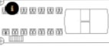360°
!iHiii!ilii
mmmm

SUN OECX

INFINITY

UPffR DECK

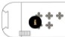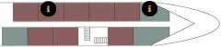RIVIERA

MAIN DECK

OCEANS

LOWER DECK

