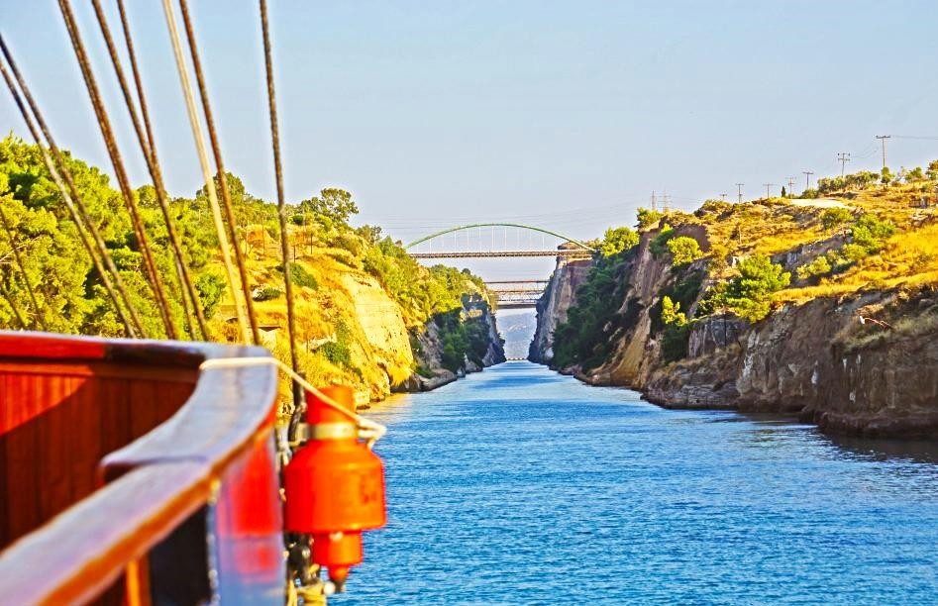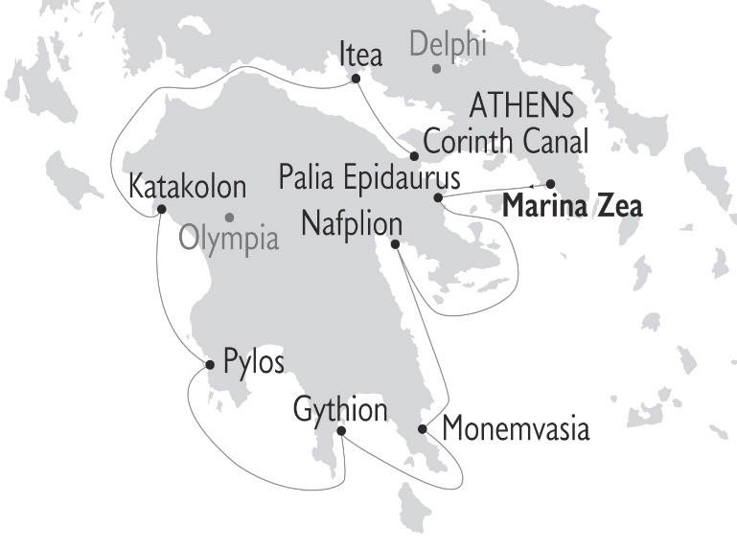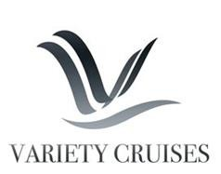
ΣΤΟΙΧΕΙΑ ΕΠΙΚΟΙΝΩΝΙΑΣ
☎ 2310 222150
e-mail: tsakiridis@tsakiridistravel.gr
Μητροπολίτου Ιωσήφ 12 Θεσσαλονίκη
www.tsakiridistravel.gr

July 15, 2021

ANTIQUITY TO BYZANTIUM CRUISE 2022
An archeology and history-themed cruise with an Expert Guest Lecturer

MARCH, APRIL, OCTOBER & NOVEMBER 2022 |
ON BOARD THE M/S GALILEO

Fridays - From Athens to Athens, Greece

A cruise voyage unraveling the world famous Corinth Canal and the most important monuments and historic sites of Greece.
Highlights include:
July 15, 2021
Mycenae · Delphi · Olympia · Corinth Canal Crossing · Ancient Epidaurus · Nafplion · Pylos

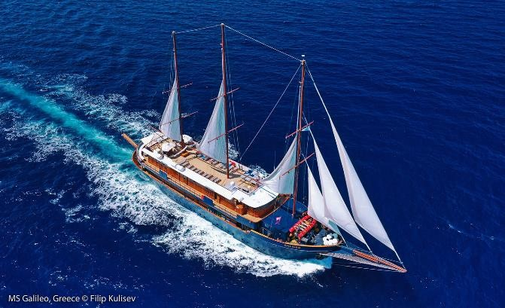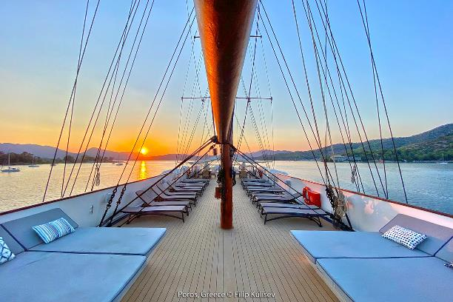
July 15, 2021

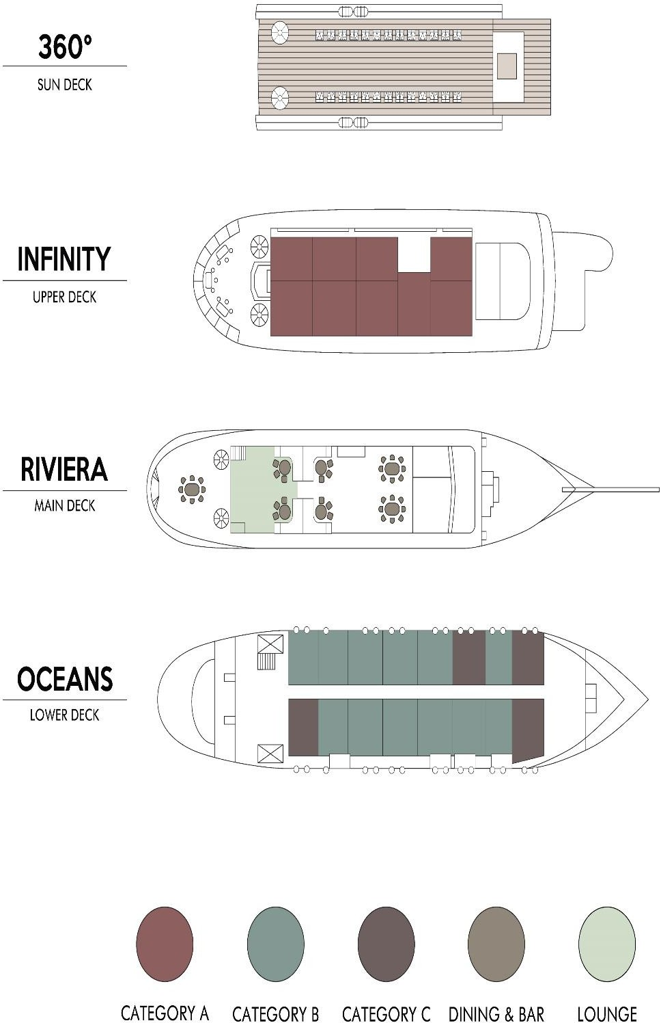

M/S GALILEO
MOTOR SAILER

The 48-meter M/S Galileo is a classic steel hull motor sailer, with spacious and well-appointed interiors renovated in 2020.
GENERAL INFORMATION:
Length: 48 m (157 ft)
Launched:1997 |Rebuilt: 2007 |Renovated:2020 Cabins: 24
Capacity: 49 passengers
Crew: 16-18

The M/S Galileo, built with the most stringent safety regulations, was launched in 1992 and was fully rebuilt in 2007. The latest renovation works of the M/S Galileo took place in summer 2020 and included significant upgrading of the indoor & outdoor public areas.
The elegant Galileo has operated cruises in the Mediterranean Sea and the Indian Ocean. The Galileo is always sailing under motors. Sails are occasionally used when weather and route allow
Service on board is provided by your Captain, the Cruise Coordinator and your experienced Marine and Hotel crew members.

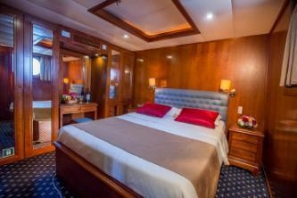
THE MOTOR SAILER GALILEO
July 15, 2021

CABIN SPECIFICATIONS:
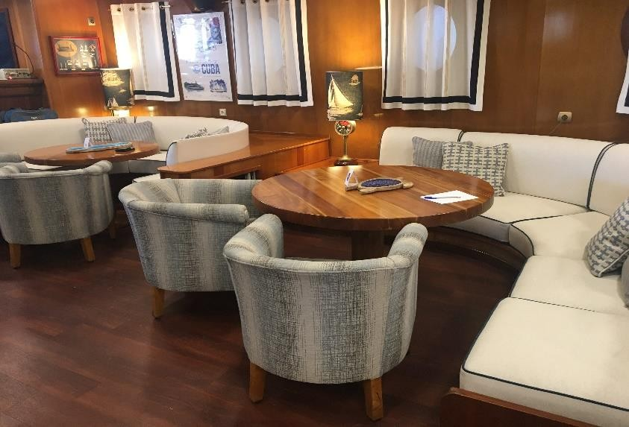
The Galileo’s 24 outside guest cabins are located on Upper and Lower Decks, all with large portholes. Elegantly decorated, they have either twin or double sized beds and bathrooms with showers ensuite. Category B cabins have flexible bedding arrangement. All cabins are comfortably arranged and beautifully furnished with wooden furniture and light fabrics. Cabins have individually controlled A/C, offer storage space, and are fitted with flat-screen TVs, mini fridge, telephone (for internal use), hairdryers, central music, public address system and safe boxes.

LIFE ON BOARD

During the day, life on board centers around the indoor lounge area and dining room, as well as the outdoor areas at the Main, Upper and Sun decks. The captain will drop anchor at secluded bays and beautiful uninhabited islands where, weather permitting, guests enjoy swimming, snorkeling, kayaking.
MAIN DECK LOUNGE & DINING ROOM
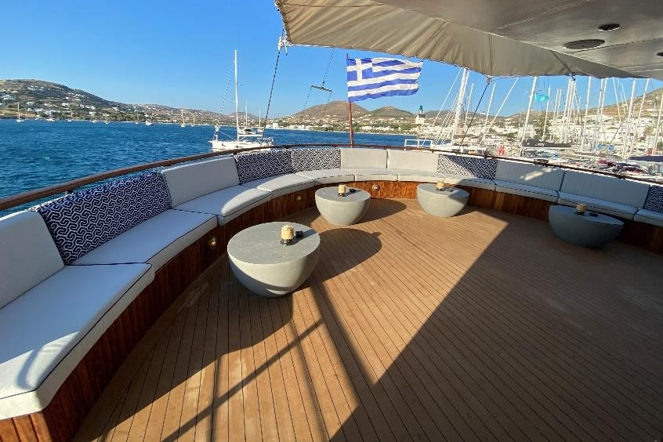
Renovated in 2020, the main deck lounge area with an American bar leads into a warm and elegant dining room finished with wood and carpet flooring, and beautiful soft fabrics. The spacious dining room seats all passengers in a single, unassigned seating and allows for spectacular views around you, while dining in an elegant environment. Food is served at the table or displayed on the state of the art hot & cold buffet which also includes an “a la minute cooking” section.
UPPER DECK OUTDOOR LOUNGE AREA
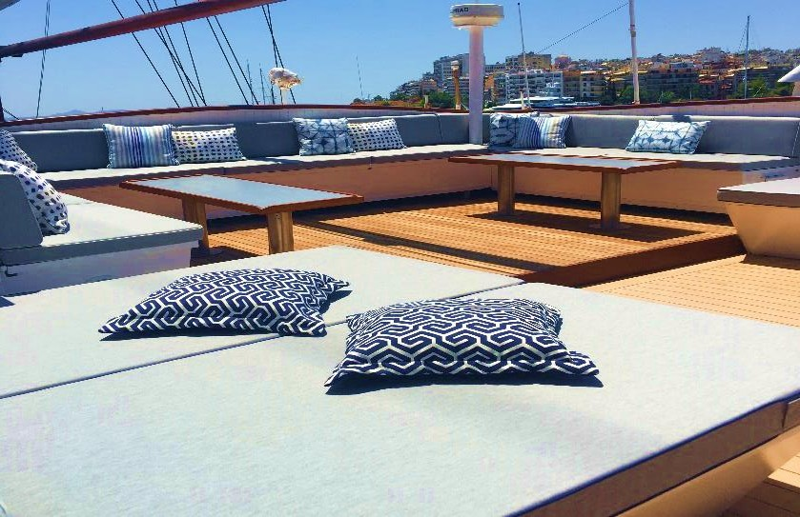
Guests on Galileo very much enjoy the shaded outdoor area with an outdoor bar where they can relax enjoying the most breathtaking sea views.

SUN DECK
The vessel features a Sun Deck with a sitting area to relax and enjoy unobstructed views and with ample Sun loungers’ space to sunbathe under the Mediterranean sun. In the evening you can watch the sunset, enjoy a drink overlooking the stars. Guests on the Galileo enjoy the shaded outdoor Bar area at the Upper Deck as well as the Sun Deck.

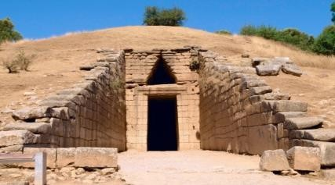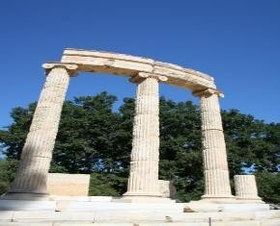
July 15, 2021

Antiquity to Byzantium Cruise Itinerary 2022
7 nights / 8 day cruises from Athens – Marina Zea

Day 1: Friday - Marina Zea
Embarkation between 2-3 pm. Enjoy a welcome drink and meet your crew and fellow passengers. Sail for Palaia (old) Epidaurus. Evening arrival and dinner on board. Overnight in port.

Day 2: Saturday - Palaia Epidaurus (optional excursion) – Nafplion
We leave our ship early in the morning to drive to Ancient Epidaurus for our optional excursion. Epidaurus was known throughout the Greek world as a healing sanctuary. It was reputed to be the birthplace of Apollo’s son Asclepius - and for its theater, which is once again in use today. The sanctuary was looted by the Roman general Sulla by pirates and later by Goths in 395 A.D. and very little remains of it today. The prosperity brought by the Asklepion enabled the residents of Epidaurus to construct civic monuments, including a huge theater (approximately 300 B.C.) renowned for its symmetry and beauty. Lunch on ship and afternoon sailing to Nafplion. Overnight in port.

Day 3: Sunday - Nafplion/Mycenae (optional excursion) - Monemvasia
After a short walking tour of Nafplion, drive through the colorful city and the beautiful countryside of Argolis towards Mycenae for an optional excursion. The importance of the city, which Homer calls “rich in gold” begins in 1650 B.C and ceases around 1100 B.C with the fall of the civilization to which it gives name. Visit the remains of the ancient glorious city including the Lion’s Gate, the Palace, the so called Agamemnon Tomb and the museum. Lunch on ship and afternoon sailing to Monemvasia. Overnight at sea.

Day 4: Monday - Gythion (optional excursion)
Early morning arrival in Gythion. Optional Excursion to Mani peninsula and Cape Tenaro plus the spectacular Dirou Caves with their stalactites and stalagmites. Ancient Gythion was inhabited during prehistoric times and later the Spartans used as a port, enlarging the natural harbor they made Gythion their naval base. Leaving Gythion we will cross the scenic Mani Peninsula to reach Diros and visit the spectacular caves, discovered around the 60s, which are perhaps among the most important natural sites of Greece. After visiting the cave we will drive to nearby Areopolis for a short stroll through the town. Mani is at the tip of the Peloponnese, a distinctive area unlike any other area in Greece. A desolate region of underground lakes and rivers, windswept landscapes and towers who is strangely beautiful. Overnight at sea.

Day 5: Tuesday - Pylos (optional excursion)
Pylos is a picture-perfect seaside town on the southwest corner of the Peloponnese. In 1827 a fleet of Venetians and other city states defeated an Ottoman fleet in one of the most important naval battles in history. This defeat led to the independence of Greece, which occurred in 1829. During our optional excursion

and after stopping to admire the scenery, we will continue up the road to Nestor’s Palace. The remains of the prehistoric Palace occupy a scenic hilltop setting north of Pylos. The palace at Pylos belonged to Nestor and was discovered in 1939 by the American archaeologist Carl Blegen. Highlights include the well-preserved royal apartments and a bathtub that archaeologists have speculated belonged to the old king himself. The palace, with its central courtyard, was originally two stories high and richly decorated with frescoes. Following our visit to the remains of the palace, we will make the short trip to the town of Hora where a superb archaeological museum holds thousands of artifacts recovered from the site. Overnight at sea.

Day 6: Wednesday - Katakolon/Olympia (optional excursion) - Itea
Early morning arrival in Katakolon. We will disembark the ship around 7:00 a.m. in the port town of Katakolon and an optional excursion takes us by bus to Olympia, one of the most famous and important sites in the ancient world. Olympia is revered as the birthplace of the Olympic Games. In the ancient Greek world, it was also the greatest Pan-Hellenic sanctuary for the worship of Zeus. Olympia persisted well into Roman times until its demise in the 3rd century A.D. when fires, earthquakes and invading tribes from the north left the ancient site in ruins. From 1875 onward excavation work, spearheaded primarily by the German government, revealed the fantastic treasures from antiquity that sit today in the marvelous archaeological museum. The most thrilling site at Olympia is the stadium, which looks much like it did more than 2,000 years ago. You will also explore the Temple of Hera, the magnificent temple of Zeus the Philippeion – lodging place for the athletes who participated in the games. We later visit the Olympia Museum, one of the most beautiful museums in the world. Following lunch in the town of Olympia, we’ll visit the museum of the History of the Olympic Games of Antiquity. Unlike the main archaeological museum, this building houses statuary and a host of artifacts specifically related to the ancient Olympic Games. After having time at leisure, we will travel overland to Patra on the north coast of the peninsula, where we will re-board our ship and depart for Itea in the Gulf of Corinth. Overnight in port.
Day 7: Thursday - Itea/Delphi (optional excursion) – Transit of Corinth Canal – Marina Zea Morning optional excursion to Delphi, one of the most revered sites from the ancient world. We will disembark the ship early this morning and proceed to the ruins complex. Unlike other archaeological sites in Greece, Delphi is built on the side of a mountain. First time visitors are awed as much for the stunning natural beauty
that surround the ruins as for the ancient buildings themselves. In its prime, Delphi was revered for its wealth and reputation, attributes which grew from the site’s location as hosting the most important oracle in the classical world. Indeed, because everything in Greece is connected to mythology, Delphi became the premier site for the worship of the god Apollo. The oracle had the ability to prophecy the future and give advice. Visitors from across the Greek world traveled here to consult with the oracle and responded by offering thanks to Apollo in the form of treasure. We will have a half day to walk around the ruins complex and visit the adjoining museum. Return to the ship and cross the Corinth Canal. Later in the evening Captain’s Farewell Dinner and sail to Marina Zea. Overnight in Marina Zea.

Day 8: Friday - Marina Zea (disembarkation): Disembarkation at 9:00 after breakfast.

Itineraries can be changed at the discretion of Variety Cruises and of the Vessel's Captain in case of adverse weather conditions - winds of 6/7 beaufort or more depending on the vessel- on port authorities not allowing a vessel to leave port or in case of other extraordinary conditions. Such itinerary changes do not entitle automatically passengers to any refunds, but Variety Cruises guarantees that passengers are disembarked at the advertised port of disembarkation on time for their flights.

ANTIQUITY TO BYZANTIUM CRUISES 2022 - SAILING DATES
From Athens, Marina Zea  Friday Sailings, on board M/S GALILEO | Low Season Departures  Mar. 18, 25  Nov. 04, 11 | High Season Departures  Apr. 01, 08, 15  Oct. 28

###

ΣΤΟΙΧΕΙΑ ΕΠΙΚΟΙΝΩΝΙΑΣ
☎ 2310 222150
e-mail: tsakiridis@tsakiridistravel.gr
Μητροπολίτου Ιωσήφ 12 Θεσσαλονίκη
www.tsakiridistravel.gr

