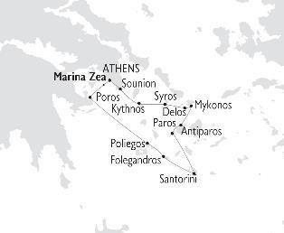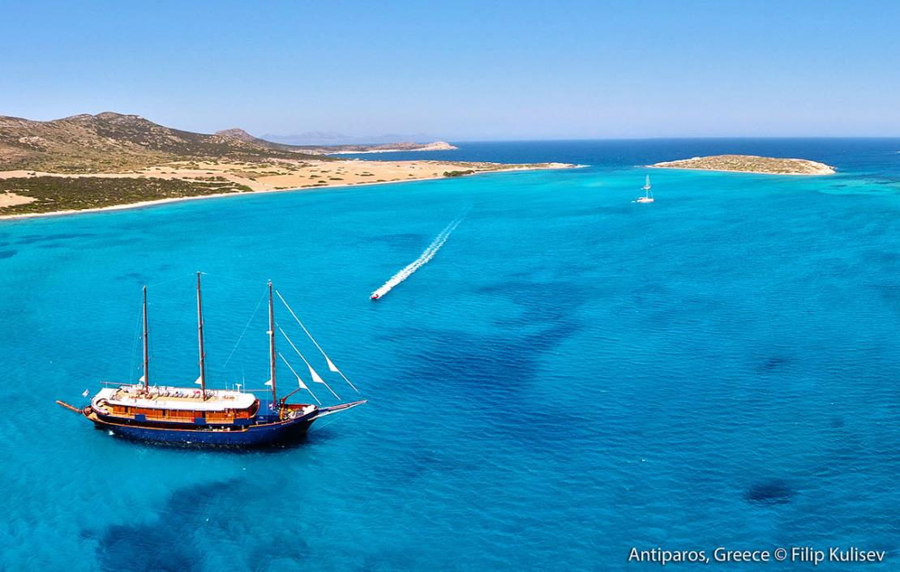
July 15, 2021

ΣΤΟΙΧΕΙΑ ΕΠΙΚΟΙΝΩΝΙΑΣ

☎ 2310 222150
e-mail: tsakiridis@tsakiridistravel.gr
Μητροπολίτου Ιωσήφ 12 Θεσσαλονίκη
www.tsakiridistravel.gr

JEWELS OF THE CYCLADES 2022

ABOARD THE 24-CABIN MOTOR SAILER GALILEO
APRIL - OCTOBER 2022 | 8-day cruises Fridays - From Athens to Athens, Greece

A cruise voyage unraveling the authentic, whitewashed islands of the Cyclades.

Highlights include:
Santorini · Mykonos · Folegandros · Poliegos · Delos · Paros · Syros · Kythnos · Poros
July 15, 2021

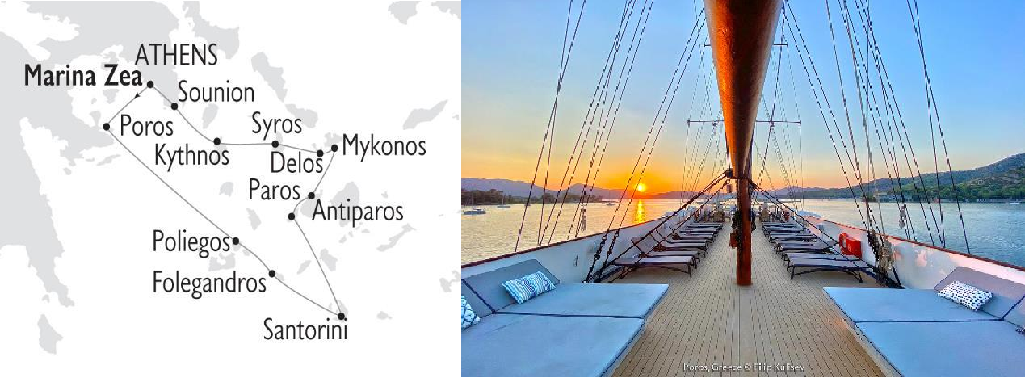
July 15, 2021

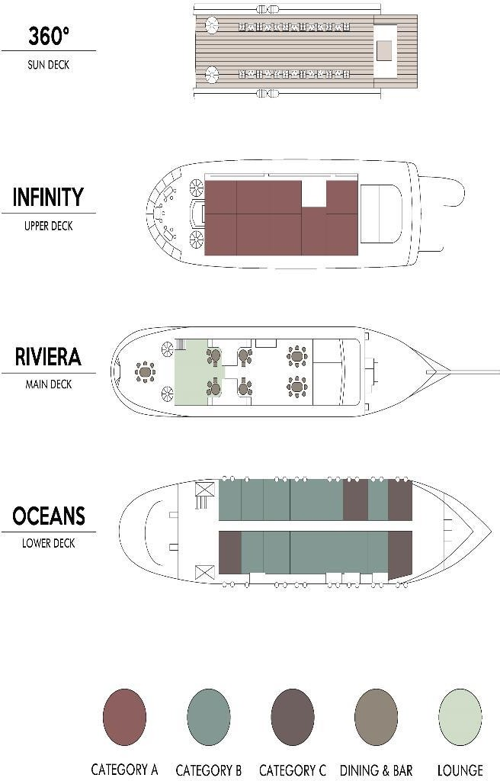
M/S GALILEO
MOTOR SAILER

The 48 meter M/S Galileo is a classic steel hull motor sailer, with spacious and well-appointed interiors renovated in 2020.
GENERAL INFORMATION:
Length: 48 m (157 ft)
Launched:1997 |Rebuilt: 2007 |Renovated:2020 Cabins: 24
Capacity: 49 passengers
Crew: 16-18

The M/S Galileo, built with the most stringent safety regulations, was launched in 1992 and was fully rebuilt in 2007. The latest renovation works of the M/S Galileo took place in summer 2020 and included significant upgrading of the indoor & outdoor public areas.
The elegant Galileo has operated cruises in the Mediterranean Sea and the Indian Ocean. The Galileo is always sailing under motors. Sails are occasionally used when weather and route allow
Service on board is provided by your Captain, the Cruise Coordinator and your experienced Marine and Hotel crew members.

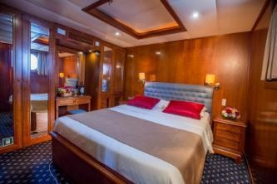
THE MOTOR SAILER GALILEO
July 15, 2021

CABIN SPECIFICATIONS:
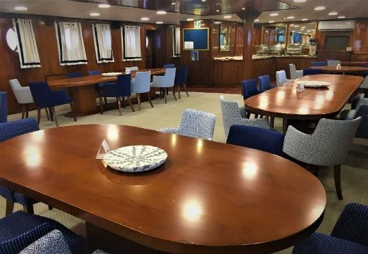
The Galileo’s 24 outside guest cabins are located on Upper and Lower Decks, all with large portholes. Elegantly decorated, they have either twin or double sized beds and bathrooms with showers en suite. Category B cabins have flex bedding arrangement. All the cabins are comfortably arranged and beautifully furnished with wooden furniture and light fabrics. Cabins have individually controlled A/C, offer storage space, and are fitted with flat-screen TV, mini fridge, telephone (for internal use), hairdryer, central music, public address system and safe boxes.

LIFE ON BOARD
During the day, life on board centers around the indoor lounge area and dining room, as well as the outdoor areas at the Main, Upper and Sun decks. The Captain will drop anchor at secluded bays in beautiful uninhabited islands where weather permitting guests can enjoy swimming, snorkeling, kayaking.

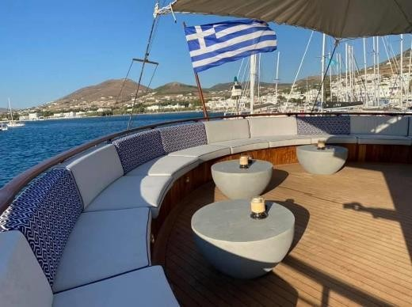
MAIN DECK LOUNGE & DINING ROOM
Renovated in 2020, the main deck lounge area with an American bar leads into a warm and elegant dining room finished with wood and carpet flooring, and beautiful soft fabrics. The spacious dining room seats all passengers in a single, unassigned seating and allows for spectacular views around you, while dining in an elegant environment. Food is served at the table or displayed on the state of the art hot & cold buffet which also includes an “a la minute cooking” section.

UPPER DECK OUTDOOR LOUNGE AREA
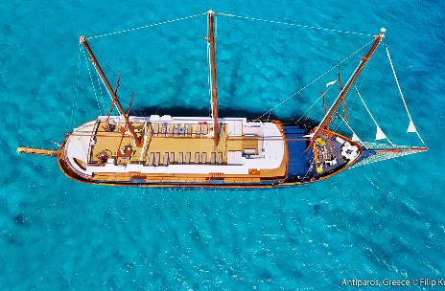
Guests on Galileo very much enjoy the shaded outdoor area with an outdoor bar where they can relax enjoying the most breathtaking sea views.

SUN DECK
The vessel features a Sun Deck with a sitting area to relax and enjoy unobstructed views and with ample Sun loungers’ space to sunbathe under the Mediterranean sun. In the evening you can watch the sunset, enjoy a drink overlooking the stars. Guests on the Galileo enjoy the shaded outdoor Bar area at the Upper Deck as well as the Sun Deck.

Cruise Highlights include:
- Santorini, with her famous sunsets, sugar-cube villages, and the historical site of Akrotiri
- Mykonos, the queen of the Aegean, and nearby Delos, Apollo's sacred island, a breath-taking open air museum and UNESCO World Heritage site
- Folegandros, a truly authentic, off-the-beaten track island, with her famous Venetian castle
- Syros, the classy capital of the Cyclades
- Paros, a fairytale with charming fishing ports

JEWELS OF THE CYCLADES CRUISES 2022
FRIDAY DEPARTURES · 7-NIGHTS/8-DAYS · FROM ATHENS TO ATHENS, GREECE
DAY 1  FRI | ATHENS- POROS GREECE | Embarkation at Marina Zea in Athens, between 2-3 pm. Enjoy a welcome drink and meet your crew and fellow passengers. Sail for Poros for a short 3 hours visit, before set sail to Poliegos. Overnight at sea.
DAY 2  SAT | POLIEGOS- FOLEGANDROS☽ GREECE | Morning arrival in Poliegos, an uninhabited island known for its amazing beaches and turquoise waters. Morning swim stop followed by a BBQ on deck. Afternoon sailing to Folegandros, one of the most amazing and less known islands in the Aegean Sea. Walk the amazing Upper city and have the possibility to taste delicacies at traditional Greek taverns. Overnight in Folegandros.
DAY 3  SUN | SANTORINI ☽  GREECE | Early in the morning depart for Santorini. Morning arrival at Santorini (occasionally at anchor) to explore its unique capital Fira. Optional Excursion to Akrotiri excavations and a tour of the villages including the small, beautiful village of Oia known for its breathtaking view over the caldera. Overnight in Santorini.
DAY 4  MON | ANTIPAROS– PAROS☽ GREECE | In the morning you will enjoy a swim stop in an enchanting bay of Antiparos. Early noon arrival in Paros. Visit Parikia and the quaint village of Naoussa. Time to have a fun night and show us your dancing skills during our famous Greek Night. Overnight in Paros.
DAY 5  TUE | DELOS- MYKONOS☽ GREECE | Optional morning tour to the unique archaeological site of Delos, antiquity’s most sacred island. Later on, we stop at one of Mykonos beautiful bays for swimming off the ship before sailing into the port of Mykonos. The island of the jet setters is yours to explore, and the night is young. Overnight in Mykonos.
DAY 6  WED | SYROS☽  GREECE | After a morning swim we will arrive in Syros, the capital of the Cycladic islands where you can enjoy one of its beautiful sandy beaches or walk-through town and enjoy the unique architecture of the buildings. Overnight in Syros.
DAY 7  THU | KYTHNOS – CAPE SOUNION- ATHENS☽ GREECE | In the morning we will arrive in Kythnos where you will enjoy a swim in Kolones bay and will then set sail for Marina Zea where we will arrive in the late afternoon via Cape Sounion, the temple of Poseidon. Captain’s Farewell Dinner and overnight in Marina Zea.
DAY 8  FRI | ATHENS  GREECE | Disembarkation at 9:00 am after breakfast.

☽OVERNIGHT IN PORT
Itineraries can be changed at the discretion of Variety Cruises and of the Vessel's Captain in case of adverse weather conditions - winds of 6/7 Beaufort or more depending on the vessel- on port authorities not allowing a vessel to leave port or in case of other extraordinary conditions. Such itinerary changes do not entitle automatically passengers to any refunds, but Variety Cruises guarantees that passengers are disembarked at the advertised port of disembarkation on time for their flights.

JEWELS OF THE CYCLADES CRUISES 2022 - SAILING DATES
From Athens, Marina Zea  Friday Sailings | 2022 – on the M/S GALILEO:  Apr: 22*, 29  May: 06, 13, 20, 27  June: 03, 10, 17, 24  July: 01, 08, 15, 22, 29  Aug: 05, 12, 19, 26  Sep: 02, 09, 16, 23, 30  Oct: 07, 14, 21
CABIN CATEGORIES | Gross EURO Rates per person in BL/TWIN
Cat C: Lower Deck, Twin or double beds | € 2,300
Cat B: Lower Deck, Flexible beds | € 2,700
Cat A: Upper Deck, Twin or double beds (Triple cabins available) | € 3,450
Single Supplement | 60% for Cat C & B Cabins  75% for Cat A Cabins
3rd Person discount in Cat A | 30%
“Children policy/Family offer as below*’’
Port Charges | € 295

*VALUE DATES DISCOUNT
-10% ON ALL CRUISE FARES FOR THE RED STAR-MARKED SAILINGS
###
ΣΤΟΙΧΕΙΑ ΕΠΙΚΟΙΝΩΝΙΑΣ

☎ 2310 222150
e-mail: tsakiridis@tsakiridistravel.gr
Μητροπολίτου Ιωσήφ 12 Θεσσαλονίκη
www.tsakiridistravel.gr

