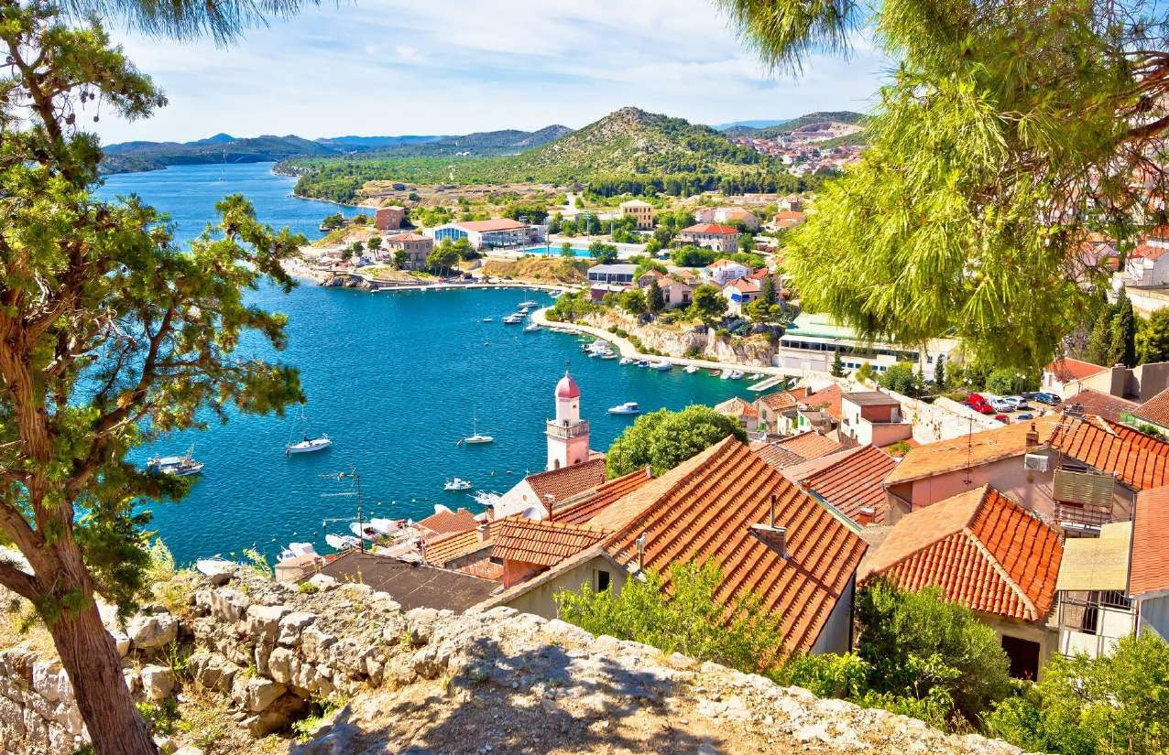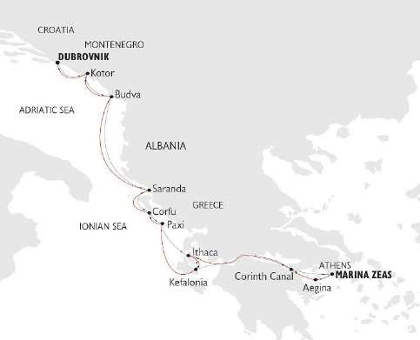
ΣΤΟΙΧΕΙΑ ΕΠΙΚΟΙΝΩΝΙΑΣ
☎ 2310 222150
e-mail: tsakiridis@tsakiridistravel.gr
Μητροπολίτου Ιωσήφ 12 Θεσσαλονίκη
www.tsakiridistravel.gr

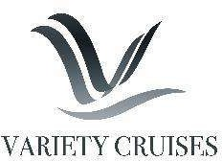

CRUISING THE ADRIATIC & GREECE 2022
CROATIA, MONTENEGRO, ALBANIA & GREECE
8-day cruises | Fridays – From Athens, Greece to Dubrovnik, Croatia, or reverse
JUNE & AUGUST 2022 | aboard the 17-cabin M/Y CALLISTO JULY 2022 | aboard the 24-cabin M/S PANORAMA
July 15, 2021
CORINTH CANAL – AEGINA – KEFALONIA – ITHACA – PAXI – CORFU – SARANDA/BUTRINT – BUDVA – KOTOR – DUBROVNIK

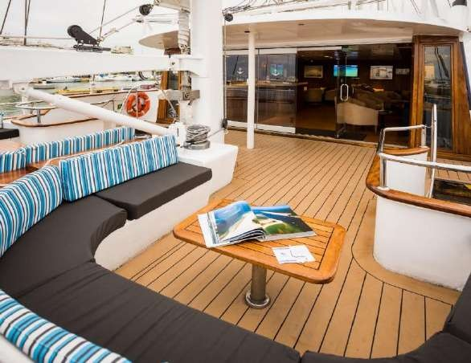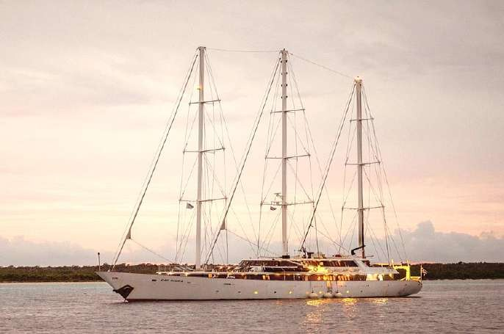
July 15, 2021

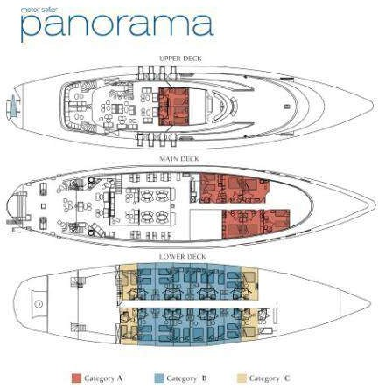
THE PANORAMA MOTOR SAILER
The M/S PANORAMA is a 54-meter elegant motor sailer accommodating just 49 passengers in 24 outside cabins.

GENERAL INFORMATION:
Length: 54 m
Launched: 1993 | Last Renovated: 2019
Cabins: 24
Capacity: 49 passengers
Crew: 16-18

The M/S PANORAMA is a 54 meter/24 cabin elegant motor sailer that was launched in 1993 and was last renovated in summer 2019. This state-of-the-art sail cruiser has performed several Atlantic Ocean crossings: she has sailed from the Seychelles to Monte Carlo and from the Black Sea to Cuba, and offers the highest standards of accommodation, comfort and safety. The vessel complies with the most stringent SOLAS safety regulations.
Service on board is provided by your Captain, the Cruise Coordinator and your experienced Marine and Hotel crew members. Service will be attentive or unobtrusive according to your preference and priority is always given to the safety and comfort of passengers. Organized excursions are available for most ports of call and can be pre-booked or reserved 24 hours in advance.
July 15, 2021

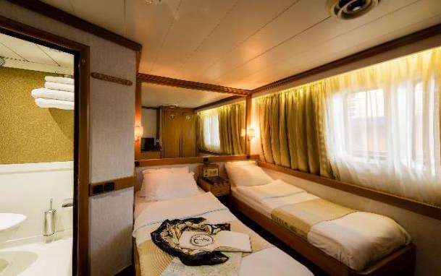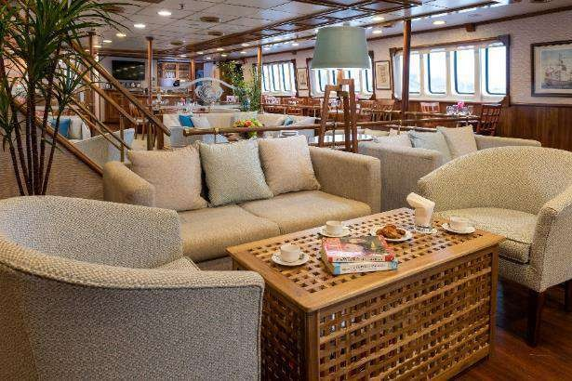THE MOTOR SAILER PANORAMA
July 15, 2021

CABIN SPECIFICATIONS:
The PANORAMA’s 24 cabins are located on 3 decks and are finished with wooden furniture and light fabrics. Cabins on the Upper and Main decks are equipped with windows, while cabins on the lower deck have portholes. The fully equipped bathrooms are finished with marble or corian materials. All cabins are air-conditioned and fitted with flat- screen TVs, telephones (for internal use), hairdryers, mini-fridges, central music, public address system and safe boxes.

LIFE ON BOARD
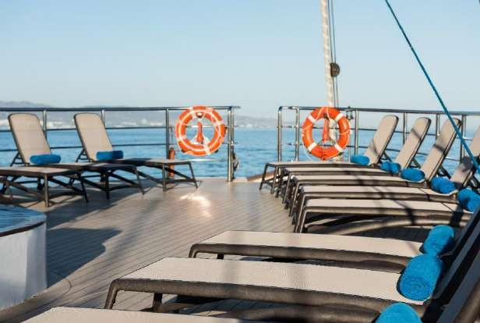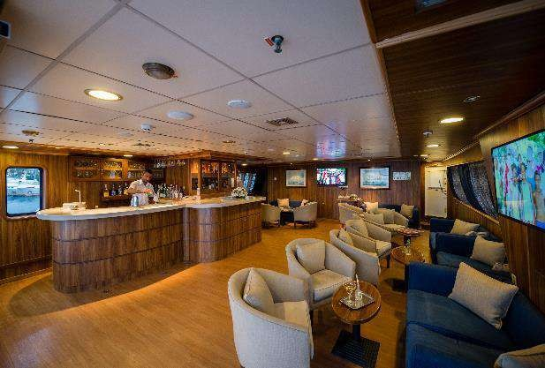During the day, life on board centers around the Lounge and Dining Room at the Main Deck as well as the Upper deck indoor and outdoor bar area and the sun deck. In the evening you can relax in one of the ship’s lounges and enjoy a drink while listening to piano music. The swimming platform on PANORAMA’s stern enables you to swim when weather and anchorage conditions permit. The captain will drop anchor at secluded bays and beautiful uninhabited islands where guests enjoy swimming, snorkeling.

MAIN DECK DINING ROOM
The classy dining room is surrounded by large windows providing beautiful views of the ports of call. The spacious dining room seats all passengers in a single, unassigned seating and food is served at the table or displayed on the state of the art hot & cold buffet which also includes an “a la minute cooking” section.

MAIN DECK & UPPER DECK LOUNGE AREAS
The interior lounges have relaxing couches and comfortable lounge chairs where you can have a drink and gaze out of the large windows into the breathtaking sceneries you are cruising to, read a book, watch television on the satellite TV or one of our documentaries on the next place you are visiting. Also located on the Upper Deck, the outdoor area provides beautiful views of the ports of call visited.

SUN DECK

The vessel features a Sun Deck with a sitting area to relax and enjoy unobstructed views and with ample Sun loungers’ space to bask under the sun, read a good book or just gaze at the scenery.
July 15, 2021

July 15, 2021
July 15, 2021

M/Y CALLISTO
MEGA YACHT

The Callisto is a 52 m /170 ft Motor Yacht which complies with the latest SOLAS regulations for International Voyages. Her state-of-the-art twin stabilizers allow for safe and comfortable cruising.
GENERAL INFORMATION:
Length: 52 m (170 ft)
Launch Year: 2000 | Fully refitted: 2015 Cabins: 17
Capacity: 34 passengers
Crew: 17

The elegant Motor Yacht Callisto joined the VARIETY CRUISES fleet in 2015 and is true to her name: Elegant, classic. She was fully refit / rebuilt in 2000 and was thoroughly renovated in 2015-16.
This classy Motor Yacht has performed several Atlantic Ocean crossings and has also sailed along the most interesting coastal sites of Europe, North and West Africa. The M/Y Callisto is of the “boutique” category of cruiser, and offers the highest standard of accommodation, comfort and safety.
Service on board is provided by your Captain, the Cruise Coordinator and your experienced Marine and Hotel crew members.

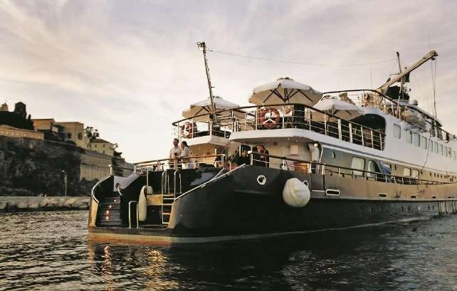
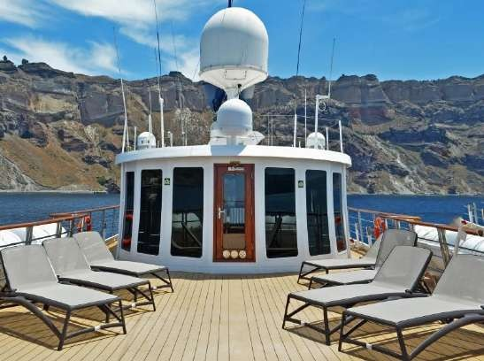

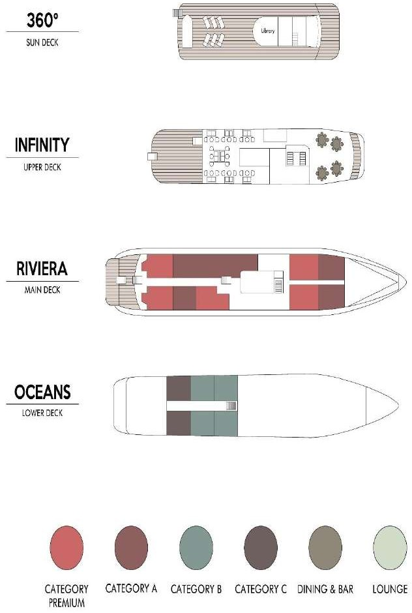

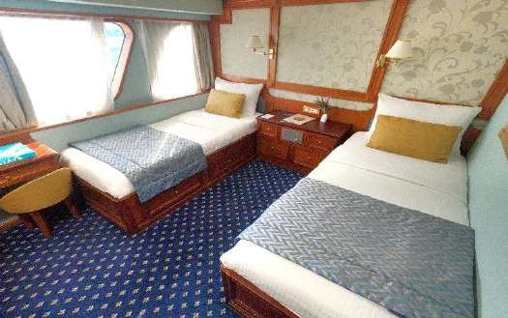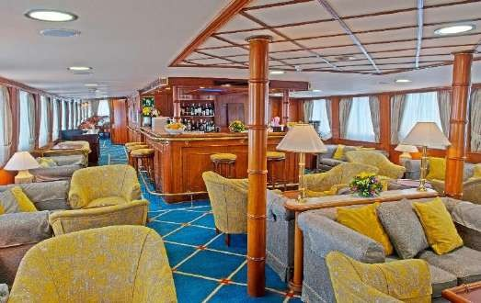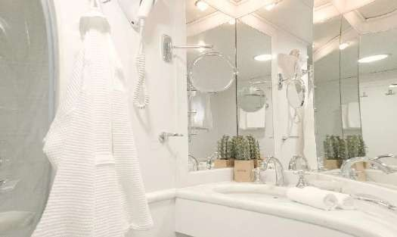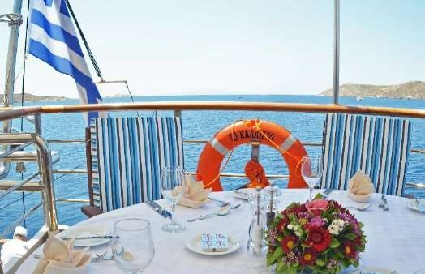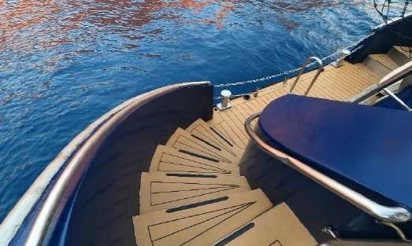

M/Y CALLISTO
July 15, 2021

MEGA YACHT

CABIN SPECIFICATIONS:
The Callisto offers 17 finely appointed exterior cabins located on the Lower and the Main decks. All cabins are comfortably arranged and beautifully furnished with wooden furniture and light fabrics. All have marble-appointed en suite bathrooms with showers and are equipped with windows (Main deck cabins) and portholes (Lower deck cabins). All cabins have individually controlled A/C and fitted with flat-screen TV, telephone (for internal use), hairdryers, mini-fridge, central music, public address system and safe boxes. Four Main deck cabins –bow section- offer 1 double bed while all other cabins in the Lower and Main decks are equipped with twin beds.

LIFE ON BOARD
The yacht’s public areas are cozy and generous, decorated with rich fabrics, handsome woodwork, gleaming brass, antiques and fine works of art. During the day, life on board centers around the indoor and outdoor areas including the Upper deck Indoor and Outdoor lounge/bar and dining areas as well as the cozy Library located on the Sun Deck.

MAIN LOUNGE
The lounge/bar and dining room on the Upper deck are connected by the gallery, displaying exquisite art and adding to the overall feeling of elegance and style. In the evening you can relax in the ship’s lounge, enjoy a drink overlooking the stars or relax with a book in the library with its wraparound windows. The spacious lounge and bar area on the Upper Deck is surrounded by large picture windows and opens onto the Outdoor Dining area.

DINING ROOM
Located on the Upper deck, the dining room seats all passengers in a single, unassigned seating and allows for spectacular views around, while dining in an elegant environment. Meals can be also served “al fresco” on the Upper Deck’s outdoor Deck, depending on weather conditions. Food is served at the table or displayed on the state of the art hot & cold buffet which also includes an “a la minute cooking” section.

SUN DECK
The yacht features a broad Sun Deck for sunbathing and the swimming platform on Callisto’s stern enables you to swim off the ship when in sheltered bays. Sun loungers are available to sunbathe in total comfort. In the evening you can relax in the ship’s lounge, enjoy a drink overlooking the stars or relax with a book in the library with its wraparound windows.
July 15, 2021

CRUISING THE ADRIATIC & GREECE: CROATIA, MONTENEGRO, ALBANIA & GREECE
FRIDAY DEPARTURES · 7-NIGHTS/8-DAYS · FROM ATHENS TO DUBROVNIK
DAY 1  Fri | MARINA ZEA ATHENS – CORINTH CANAL GREECE | Embarkation between 2 and 3 pm. Departure at 3:30 pm towards the Corinthian gulf and late afternoon transiting of the Corinth Canal. Enjoy a welcome drink and meet your crew and fellow passengers. Welcome dinner and overnight at sea towards the island of Kefalonia.
DAY 2  Sat | KEFALONIA - ITHACA GREECE ☽ | Early morning arrival in Sami port of Kefalonia. Morning optional excursion. The island is not only known for Captain Corelli’s Mandolin, the 2001 film, but also because of its sheer beauty, its National Park and its stately towns. Early in the afternoon, we sail towards Ithaca. Enjoy a refreshing swim stop and a BBQ lunch on board. Afternoon arrival at Ithaca port of Vathy. Built within this deep-water fjord-like bay, the capital of the island maintains its charm and its traditional Ionian architecture. This island is the homeland of Homer’s Odysseus. Overnight in port.
DAY 3  Sun | ANTIPAXI - PAXI  GREECE ☽ | Early morning sailing to Antipaxi, the smallest of the Ionian Islands, for a refreshing swim stop. The island boasts a dense forest of mastic, pine, myrtle and cypress trees interspersed with grapevines. Midday arrival, swim stop and a BBQ lunch on board. Late afternoon arrival in nearby Paxi, an off- the-beaten track island with fjord-shaped beaches and port, covered with olive groves. Afternoon at leisure and overnight in port.
DAY 4  Mon | CORFU ISLAND  GREECE ☽ | Early morning sailing to Corfu Island, the Grand Lady of the Ionian Islands and the greenest island in Greece. Optional excursion to explore Corfu’s imperial past; the impressive historic center, declared UNESCO World Heritage site and the byzantine churches, or optional scenic tour through the lush Corfiot countryside and old high hill villages. Overnight in port.
DAY 5  Tue | SARANDA  ALBANIA | Early morning sailing and arrival to the charming town of Saranda, boasting the most attractive waterfront on the Albanian Riviera. Join the optional excursion to the nearby archaeological site of Butrint, an UNESCO World Heritage Site. Return to the ship for lunch on board and a swim-stop on the way. Overnight at sea to Budva, Montenegro.
DAY 6  Wed | BUDVA - KOTOR  MONTENEGRO ☽ | Morning arrival at the well-preserved medieval town of Budva. After breakfast, enjoy an optional sightseeing excursion to Old Budva. Explore Budva’s vast cultural heritage and Venetian architecture. Late afternoon departure to Kotor, Montenegro. Navigation in the Bay of Kotor, the deepest natural fjord in the Mediterranean. Overnight in port.
DAY 7  Thu | KOTOR, MONTENEGRO – DUBROVNIK, CROATIA ☽ | Join the optional morning excursion to Kotor’s well-preserved, fortified medieval Old Town. Afternoon sailing and evening arrival to Dubrovnik, Croatia. Overnight in port.
DAY 8  Fri | DUBROVNIK  CROATIA | Disembarkation at 9:00 am after breakfast.

☽OVERNIGHT IN PORT
Itineraries can be changed at the discretion of Variety Cruises and of the Vessel's Captain in case of adverse weather conditions
- winds of 6/7 beaufort or more depending on the vessel- on port authorities not allowing a vessel to leave port or in case of other extraordinary conditions. Such itinerary changes do not automatically entitle passengers to any refunds, but Variety Cruises guarantees that passengers are disembarked at the advertised port of disembarkation on time for their flights.

CRUISING THE ADRIATIC & GREECE: CROATIA, MONTENEGRO, ALBANIA & GREECE
FRIDAY DEPARTURES · 7-NIGHTS/8-DAYS · FROM DUBROVNIK TO ATHENS
DAY 1  Friday | DUBROVNIK, CROATIA – KOTOR, MONTENEGRO☽ | Embarkation between 2 and 3 pm. Departure at 4 pm towards Kotor. Enjoy a welcome drink and meet your crew and fellow passengers. Navigation in the Bay of Kotor, the deepest natural fjord in the Mediterranean. Welcome dinner and overnight in port.
DAY 2  Saturday | KOTOR – BUDVA  MONTENEGRO | Join the optional morning excursion to the well-preserved, fortified medieval Old Town. Lunch on board and sailing towards Budva. Afternoon arrival at the well-preserved medieval town of Budva. Enjoy an optional sightseeing excursion to Old Budva. Explore Budva’s vast cultural heritage and Venetian architecture. Dinner and sailing to Saranda, Albania. Overnight at sea.
DAY 3  Sunday | SARANDA, ALBANIA – CORFU, GREECE ☽ | Early afternoon arrival to the charming town of Saranda, boasting the most attractive waterfront on the Albanian Riviera. Join the optional excursion to the nearby archaeological site of Butrint, a UNESCO World Heritage Site. Return to the ship for dinner and sail towards Corfu, Greece. Late evening arrival at Corfu. Overnight in port.
DAY 4  Monday | CORFU – PAXI  GREECE ☽ | Explore Corfu, the Grand Lady of the Ionian Islands and the greenest island in Greece. Optional excursion to explore Corfu’s imperial past; the impressive historic center declared UNESCO World Heritage site and the byzantine churches. Lunch on board and sailing to Paxi island, with a swim stop on the way. Evening arrival at Paxi, an off-the- beaten track island with fjord shaped beaches and port and covered with olive groves. Evening at leisure and overnight in port.
DAY 5  Tuesday | KEFALONIA  GREECE ☽ | Midday arrival in Sami port of Kefalonia. Lunch on board and afternoon optional excursion. The island is not only known for Captain Corelli’s Mandolin, the 2001 film, but also because of its sheer beauty, its National Park, and its stately towns. Overnight in Sami port.
DAY 6  Wednesday | KEFALONIA – ITHACA  GREECE | Morning sailing to Ithaca. Enjoy a refreshing swim stop and a BBQ lunch on board. Early afternoon arrival at Ithaca port of Vathy. Built within this deep-water, fjord-like bay, the capital of the island maintains its charm and its traditional Ionian architecture. This island is the homeland of Homer’s Odysseus. Afternoon at leisure to explore the island’s quaint port and cobblestone streets. Return on board for dinner and sail towards the Corinthian Gulf. Overnight at sea.
DAY 7  Thursday | CORINTH CANAL CROSSING – AEGINA, GREECE | This morning we cross the Corinth Canal, one of the most important projects of modern Greece, which played a catalytic role for the Mediterranean trade. Enjoy a BBQ Lunch and swim-stop on the way to Aegina Island. Early afternoon arrival at Aegina, a charming island in the Saronic Gulf. Afternoon at leisure to explore the well-preserved columns of the Temple of Aphaia, an ancient temple predating the Parthenon, or to stroll through mediaeval Aegina and taste local freshly roasted pistachios. Late evening sailing to Athens. After midnight, we arrive at Marina Zea, Athens.
DAY 8  Friday | MARINA ZEA ATHENS  GREECE | Disembarkation at 9:00 am after breakfast.

☽OVERNIGHT IN PORT
Itineraries can be changed at the discretion of Variety Cruises and of the Vessel's Captain in case of adverse weather conditions
- winds of 6/7 beaufort or more depending on the vessel- on port authorities not allowing a vessel to leave port or in case of other extraordinary conditions. Such itinerary changes do not automatically entitle passengers to any refunds, but Variety Cruises guarantees that passengers are disembarked at the advertised port of disembarkation on time for their flights.

CRUISING THE ADRIATIC & GREECE: CROATIA, MONTENEGRO, ALBANIA & GREECE
On board M/S Panorama & M/Y Callisto SAILING DATES
FROM ATHENS/MARINA ZEA, Greece TO DUBROVNIK, Croatia  Friday Sailings | 03 June 2022 (MY Callisto)  01 July 2022 (M/S Panorama)  19 Aug 2022 (M/Y Callisto)
FROM DUBROVNIK, Croatia TO ATHENS/MARINA ZEA, Greece  Friday Sailings | 08 July 2022 (M/S Panorama)

###

ΣΤΟΙΧΕΙΑ ΕΠΙΚΟΙΝΩΝΙΑΣ
☎ 2310 222150
e-mail: tsakiridis@tsakiridistravel.gr
Μητροπολίτου Ιωσήφ 12 Θεσσαλονίκη
www.tsakiridistravel.gr

