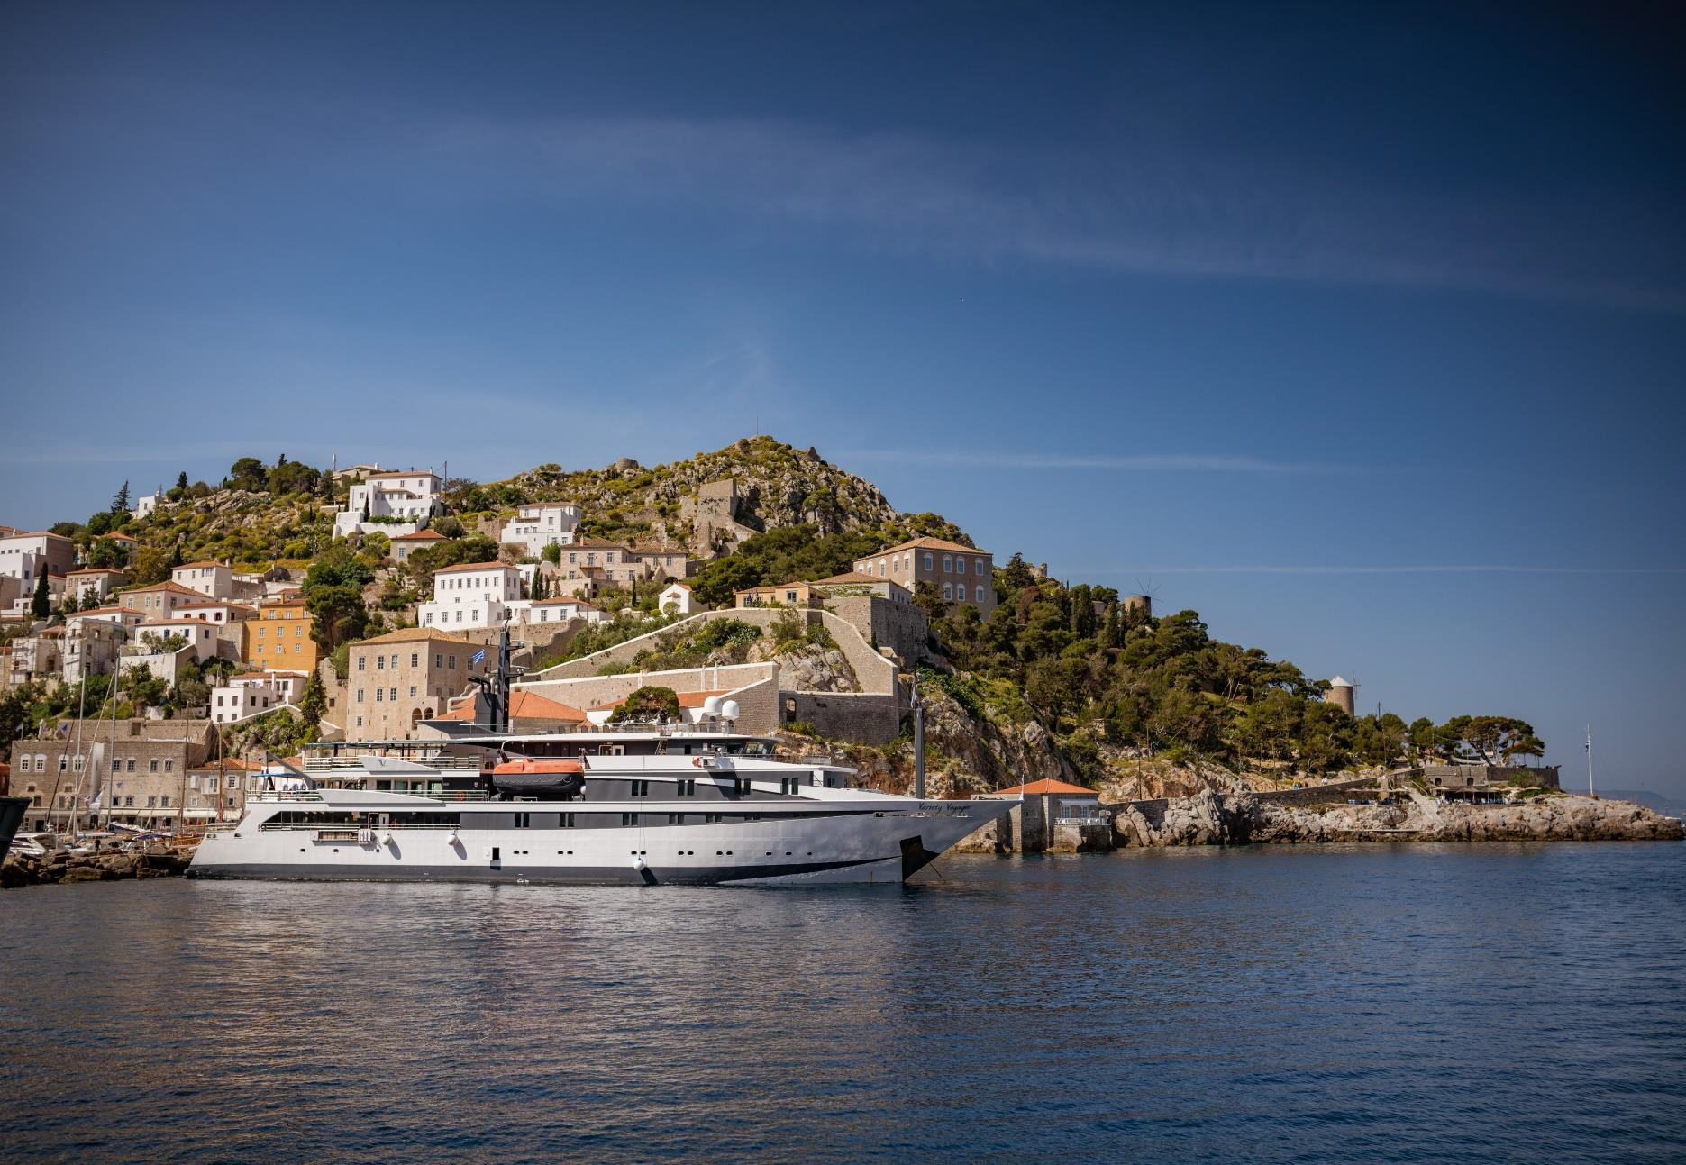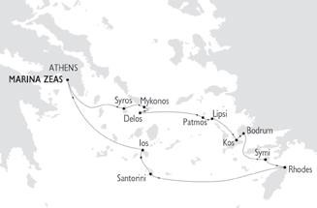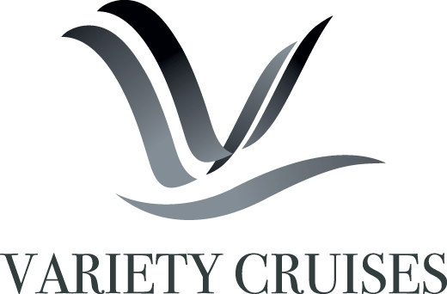
ΣΤΟΙΧΕΙΑ ΕΠΙΚΟΙΝΩΝΙΑΣ
☎ 2310 222150
e-mail: tsakiridis@tsakiridistravel.gr
Μητροπολίτου Ιωσήφ 12 Θεσσαλονίκη
www.tsakiridistravel.gr

July 8, 2021

THE BEST OF GREECE & TURKEY
The Cyclades and Dodecanese islands and Bodrum
7 NIGHT / 8 DAY CRUISES – on the 36-CABIN VARIETY VOYAGER
APRIL – OCTOBER 2022
ATHENS / MARINA ZEAS TO ATHENS / MARINA ZEAS

Highlights include:
Delos – Mykonos – Lipsi - Patmos – Bodrum – Kos – Simi – Rhodes – Santorini – Syros - Ios
July 8, 2021

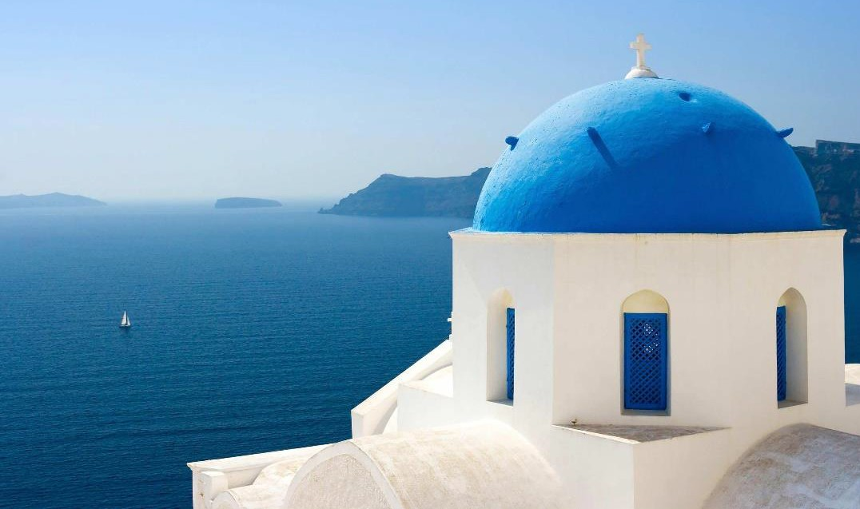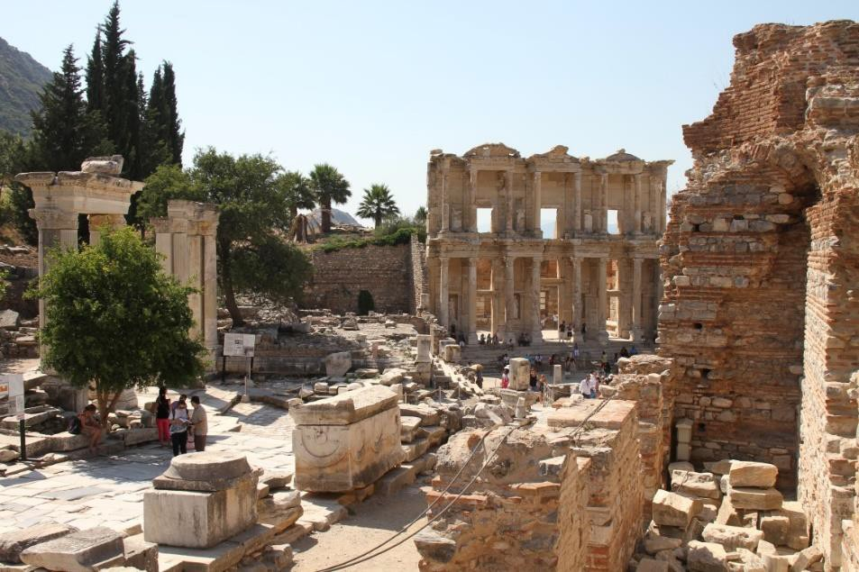
July 8, 2021

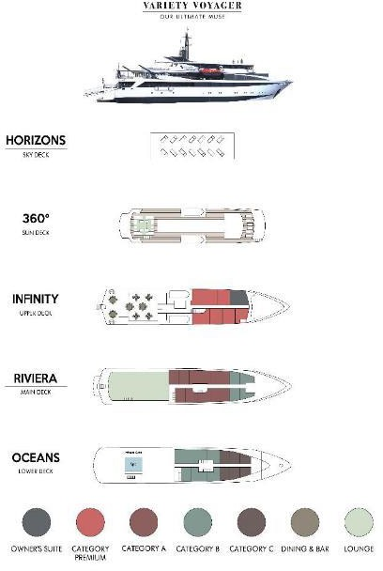
VARIETY VOYAGER MEGA YACHT
The 68-meter / 36-cabin Variety Voyager was launched in 2012. This sleek high-tech looking Mega Yacht complies with the most stringent SOLAS safety regulations

GENERAL INFORMATION:
Length: 68 m – 223 ft
Launch Year: 2012
Cabins: 36
Capacity: 72 passengers
Crew: 32

CABIN SPECIFICATION:

The 68-meter Mega Yacht Variety Voyager accommodates up to 72 guests in 36 cabins. 28 cabins are located in the Main and Lower Decks, and 8 staterooms sizes range from 16-20 m². Cabins at the Lower deck feature two oversized portholes and cabins at the Main and the Upper deck feature large windows. All cabins have individually controlled A/C and ventilation, mini-fridge, flat-screen TVs and DVD players. Bathrooms are finished with warm marble and Corian materials.
July 8, 2021

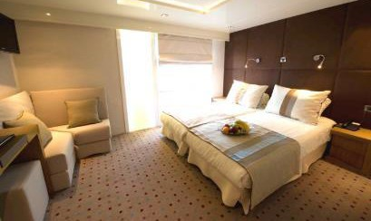
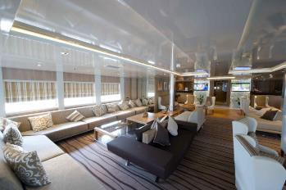M/Y VARIETY VOYAGER
LIFE ON BOARD
July 8, 2021
MAIN LOUNGE
Located on the Main deck, right off the reception area, the Main Lounge is gracefully designed and finished with wood panels. There is ample seating space for moments of pleasure or relaxation and modern AV equipment for presentations. The mini library, just off the Main Lounge, offers a variety of books and magazines.

DINING ROOM
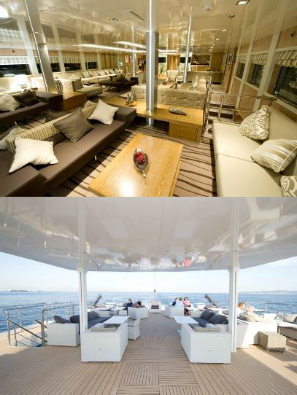
Located on the Upper deck, the glass enclosed dining room seats 75 and allows for spectacular views around you, while dining in an elegant environment. It extends to the adjacent open deck dining room, also seating 50 passengers and allowing for breakfast, lunch or dinner to be taken “al fresco”. Food is served at the table or displayed on the state of the art hot & cold buffet which also includes an “a la minute cooking” section.

OCEAN'S BAR & LOUNGE
Located on the 360° Sun Deck, the open Bar and Lounge offers stylish shaded seating and is the ideal spot for reading, relaxing or dancing under the stars until the late hours at the sound of our resident DJ/entertainer.

SPA & FITNESS SUITE
Located at the Lower Deck, it offers Massage, Sauna and some fitness equipment. Our Balinese Spa Supervisor also provides hair, face and nails treatments.

SUN DECK / SKY DECK
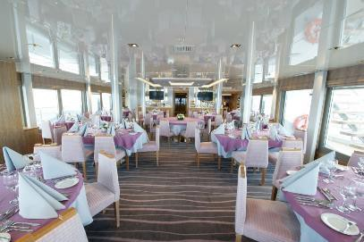
Sun loungers are available to sunbathe in total comfort while enjoying drinks served from the Ocean’s Bar.

July 8, 2021

BEST OF GREECE & TURKEY 2022

Day 1 – MARINA ZEA, ATHENS – CAPE SOUNION
Embarkation 14:00-15:00. We sail to Cape Sounion. Late in the afternoon, we reach Cape Sounion for Welcome Cocktails & dinner at anchor under the Temple of Poseidon. Departure and overnight at sea to Ios.

Day 2 IOS/MANGANARI BEACH – SANTORINI
In the morning, we stop for a refreshing swim at Manganari Beach/ Ios, one of the most beautiful beaches in Greece. After midday, we reach Santorini, formed by the half-submerged crescent of a volcanic caldera. You will go ashore and take a cable car to the town of Fira, a stunning cluster of white buildings atop a cliff. Afternoon optional tour to Akrotiri, a city buried in the eruption that created the caldera in 1600 B.C and to Fira. The tour will end in Oia, famous for its sun set. Overnight at sea to Rhodes
Day 3 RHODES – SIMI
Morning arrival in Rhodes. The island’s medieval Old Town is one of the best preserved mediaeval settlements in the world and has been declared a UNESCO World Heritage Site. Morning Optional excursion and early afternoon sailing to nearby Simi Island, with a swim stop on the way. Late afternoon arrival at Simi, evening at leisure. Overnight in port.
Day 4 SIMI – BODRUM – KOS
Early morning sailing to Bodrum- Turkey. optional tour to Halicarnassus, famous for the Mausoleum of Halicarnassus, also known simply as the Tomb of Mausolus, whose name provided the origin of the word "mausoleum". Early afternoon sailing to Kos, lying on the edge of the Dodecanese. Afternoon at leisure to explore the island’s Tall palm trees, endless sandy beaches, alternating landscapes and numerous archaeological sites and attractions left by ancient Greeks, Romans, mediaeval knights, Venetians and Ottomans. Overnight in port.
Day 5 KOS – LIPSI – PATMOS
Morning sailing from Kos. Swim stop and beach BBQ in Lipsi island, before sailing to Patmos. Early afternoon arrival in Patmos and optional Patmos excursion includes two UNESCO World Heritage Sites, the Grotto and Monastery of St. John and the historic center of the medieval town of Chora. Evening at leisure to discover Scala, the capital, or swim at a nearby beach. Overnight in Patmos.
Day 6 DELOS - MYKONOS
This morning, enjoy breakfast at anchor in Delos. Enjoy an optional visit to tiny Delos, the mythical birthplace of Apollo and Artemis. On an optional guided walking tour, you’ll visit the archaeological ruins of this UNESCO World Heritage Site, unearthed here in the 19th century. Delos is a true open-air museum with many ancient monuments and buildings that are remarkably intact. After our tour, we enjoy a refreshing swim stop and deck BBQ lunch, weather permitting. Later in the afternoon we sail into Mykonos Harbor. While exploring the town, you can visit the Archaeological Museum or the Maritime museum, and make sure you enjoy Mykonos world famous night life! Overnight in Mykonos.

Day 7 SYROS
After breakfast, we sail towards Syros. Morning swim stop followed by a BBQ on deck. Early afternoon arrival at Syros, the capital of the Cycladic islands. Discover Ermoupoli, port and capital of Syros, with her marble flagstones paving its spacious main square, presided over by the grandiose Town Hall, one of the 19th-century masterpieces of Ernst Ziller, the famous Saxon architect who became a Greek national. Optional afternoon walking tour. Captain’s Farewell Dinner on board and overnight at sea to Marina Zea, Athens.
Day 8 MARINA ZEA, ATHENS
Disembarkation at 9:00 am after breakfast.

☽OVERNIGHT IN PORT
Itineraries can be changed at the discretion of Variety Cruises and of the Vessel's Captain in case of adverse weather conditions - winds of 6/7 beaufort or more depending on the vessel- on port authorities not allowing a vessel to leave port or in case of other extraordinary conditions. Such itinerary changes do not entitle automatically passengers to any refunds but Variety Cruises guarantees that passengers are disembarked at the advertised port of disembarkation on time for their flights.

BEST OF GREECE 2022
SAILING DATES
From Athens, Marina Zea  Friday Sailings | Apr: 15*, 22*, 29* May: 06, 13, 20, 27  June: 03, 10, 17, 24  July: 01, 08, 15, 29  Aug: 05, 12, 19, 26  Sep: 02, 09, 16, 23, 30  Oct: 07, 14, 21, 28

*VALUE DATES DISCOUNT:
-10% ON ALL CRUISE FARES FOR THE STAR-MARKED SAILINGS
VALUE DATE DISCOUNT IS COMBINABLE WITH EARLY BOOKING DISCOUNT.

###

ΣΤΟΙΧΕΙΑ ΕΠΙΚΟΙΝΩΝΙΑΣ
☎ 2310 222150
e-mail: tsakiridis@tsakiridistravel.gr
Μητροπολίτου Ιωσήφ 12 Θεσσαλονίκη
www.tsakiridistravel.gr

